**Tugas Praktikum Konsep Pemrograman**

**Modul Praktikum 24 – Pointer 1**

Nama : Irvan Aditya Kurniawan

Kelas : 1 D4 IT B

NRP : 3124600044

**SOAL :**

**Untuk setiap program dibawah ini,**

* **Gambarkan Ilustrasi alokasi memori dari setiap baris pernyataan yang diproses**
* **Perkirakan hasil eksekusinya**

* **Illustrasi Alokasi :**

|  |  |  |
| --- | --- | --- |
| Variabel | Alamat | Value |
| x | **0060FEF1** | **87** |
| y | **0060FEF2** | **87** |
| *px | **0060FEF3** | **0060FEF1** |

* **Hasil Eksekusi :**

Alamat x = 0060FEF1

Isi px = 0060FEF4

Isi x = 87

Nilai yang ditunjuk oleh px = 87

Nilai y = 87

1. A white background with black text

   Description automatically generated

* **Illustrasi Alokasi :**

|  |  |  |
| --- | --- | --- |
| Variabel | Alamat | Value |
| *pu | **0060FEF1** | **0060FEF3** |
| nu | **0060FEF2** | **0.000** |
| u | **0060FEF3** | **1234.0** |

* **Hasil Eksekusi :**

Alamat dari u = 0060FEF0

Isi pu = 0060FEF0

Isi u = 1234.000000

Nilai yang ditunjuk oleh pu = 0.000000

Nilai nu = 0.000000

1. 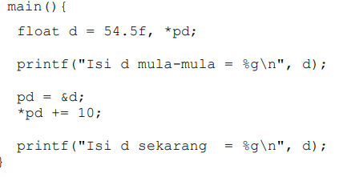

* **Ilustrasi Alokasi :**

|  |  |  |
| --- | --- | --- |
| Variabel | Alamat | Value |
| *pd | **0060FEF2** | **0060FEF1** |
| d | **0060FEF1** | **54.5 64.5** |

* **Hasil Eksekusi :**

Isi d mula-mula = 54.5

Isi d sekarang = 64.5

1. 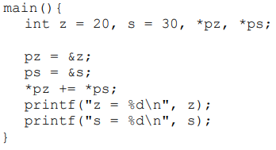

* **Ilustrasi Alokasi :**

|  |  |  |
| --- | --- | --- |
| Variabel | Alamat | Value |
| z | **0060FEF1** | **20 50** |
| s | **0060FEF2** | **30** |
| *pz | **0060FEF3** | **0060FEF1** |
| *ps | **0060FEF4** | **0060FEF2** |

* **Hasil Eksekusi :**

Isi d mula-mula = 54.5

Isi d sekarang = 64.5

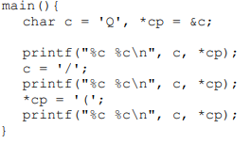



* **Ilustrasi Alokasi :**

|  |  |  |
| --- | --- | --- |
| Variabel | Alamat | Value |
| c | **0060FEF1** | **Q / (** |
| *cp | **0060FEF2** | **0060FEF1** |

* **Hasil Eksekusi :**

Q Q

/ /

( (

1. 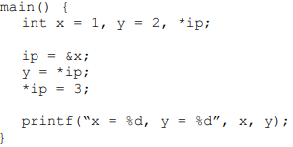

* **Ilustrasi Alokasi :**

|  |  |  |
| --- | --- | --- |
| Variabel | Alamat | Value |
| x | **0060FEF1** | **1 3** |
| y | **0060FEF2** | **2 1** |
| *ip | **0060FEF3** | **0060FEF1** |

* **Hasil Eksekusi :**

x = 3, y = 1

1. 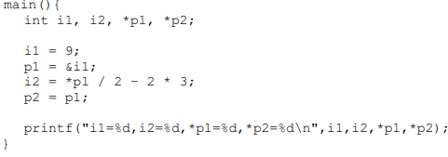

* **Ilustrasi Alokasi :**

|  |  |  |
| --- | --- | --- |
| Variabel | Alamat | Value |
| i1 | **0060FEF1** | **9** |
| i2 | **0060FEF2** | **-2** |
| *p1 | **0060FEF3** | **0060FEF1** |
| *p2 | **0060FEF4** | **0060FEF1** |

* **Hasil Eksekusi :**

i1=9,i2=-2,*p1=9,*p2=9